**Differences in program for v1.8 and v2.6**

**Sending Data to InfluxDB Server v2.6**

**influxsimplev2.py**

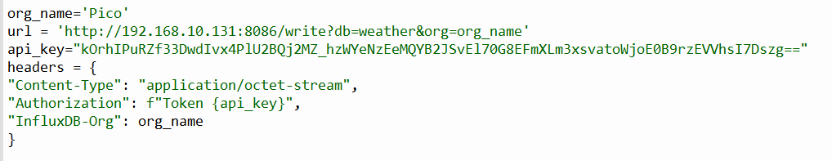

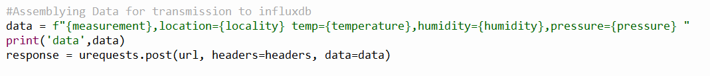

**Sending Data to InfluxDB Server v1.8**

**influxsimple.py**



